SELECT * FROM airport;

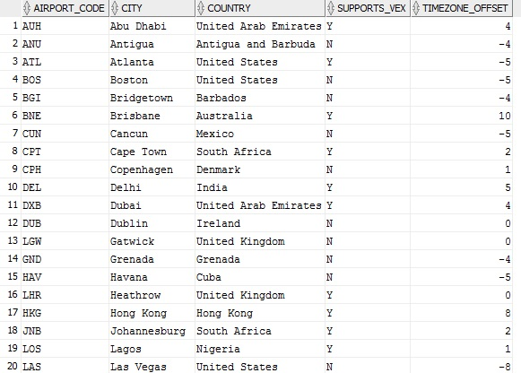

SELECT * FROM customer;

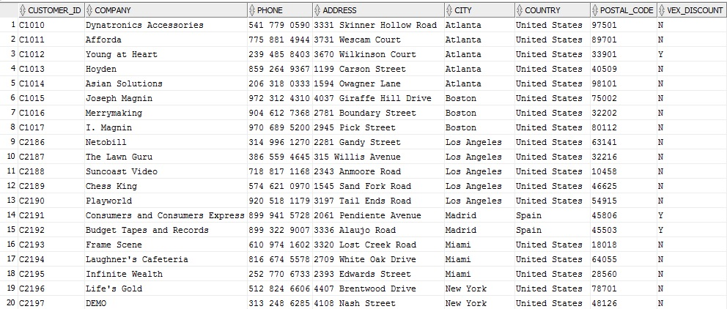

SELECT * FROM flight;

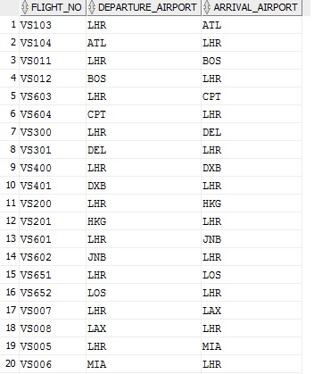

SELECT * FROM flight_schedule;

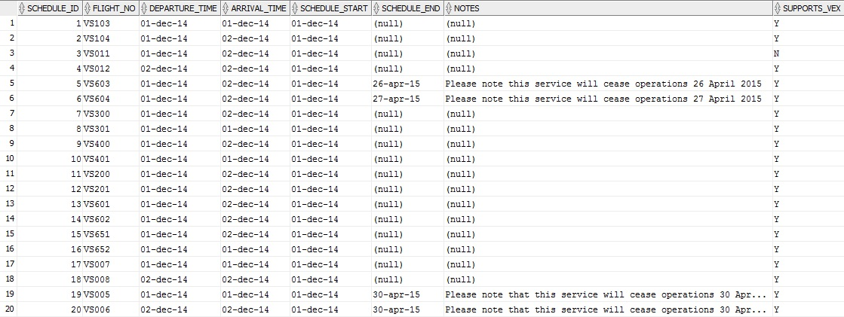

SELECT * FROM scheduled_days;

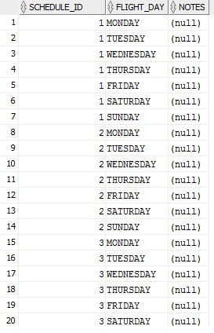

SELECT * FROM actual_flight;

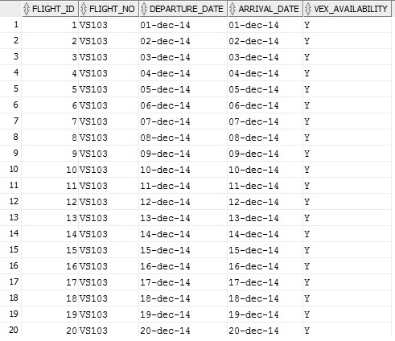

SELECT * FROM shipment;

